 | 12.1.39 Editors - Geometry Nodes Editor - Header - Add Menu - Utilities - Matrix
Table of content
Detailed table of content 1
Add menu - Utilities - Matrix 2
Boolean Math 2

Detailed table of content
Detailed table of content
Detailed table of content 1
Add menu - Utilities - Matrix 2
Boolean Math 2
Inputs 2
Boolean 2
Properties 2
Operation 2
And 2
Or 2
Not 2
Not And (NAND) 2
Nor (NOR) 2
Equal (XNOR) 2
Not Equal (XOR) 3
Imply (IMPLY) 3
Subtract (NIMPLY) 3
Output 3
Boolean 3

Add menu - Utilities - Matrix
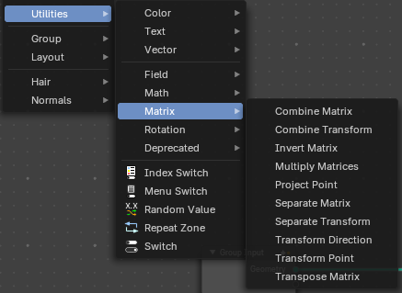
Matrix nodes.

DOCUMENT ME !

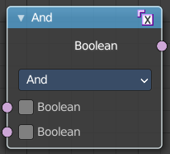
Boolean Math
The Boolean Math node performs a basic logical operation between its inputs.

Inputs

Boolean
Two standard Boolean inputs.

Properties

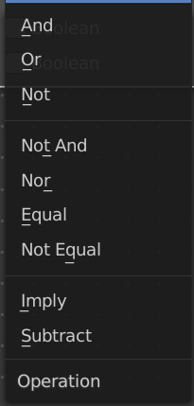
Operation

And
True if both inputs are true.

Or
True if either or both inputs are true.

Not
True if both inputs are false.

Not And (NAND)
True when at least one input is false.

Nor (NOR)
True when both inputs are false.

Equal (XNOR)
True when both inputs are equal.

Not Equal (XOR)
True when both inputs are different.

Imply (IMPLY)
True unless the first input is true and the second is false.

Subtract (NIMPLY)
True when the first input is true and the second is false.

Output

Boolean
Standard Boolean output.

